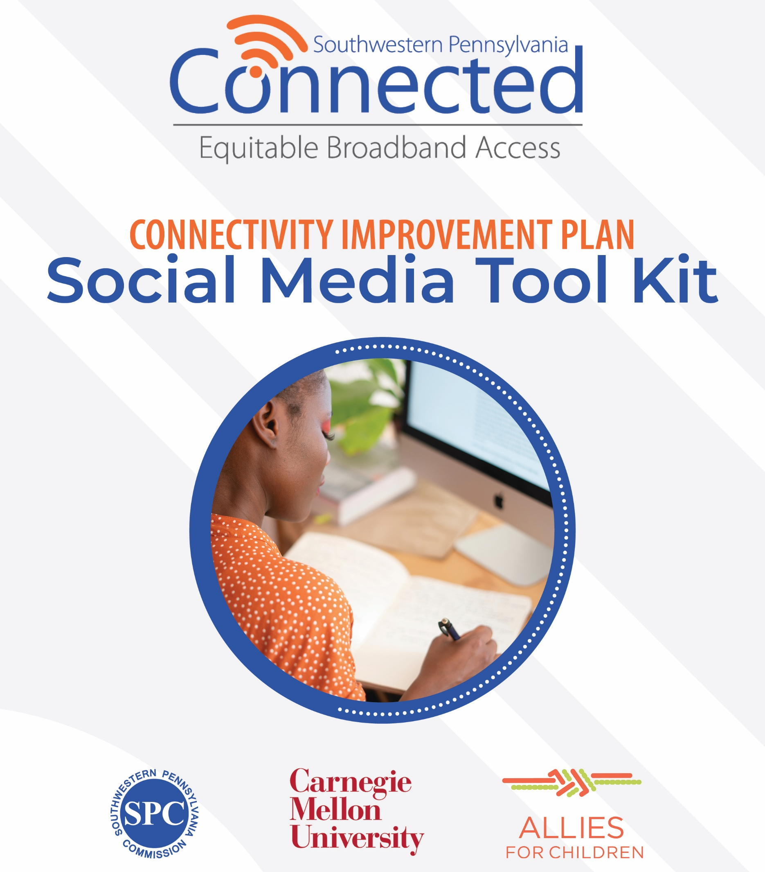

Social Media Tool Kit
This tool kit aims to provide helpful resources and materials to assist your organization in promoting and encouraging engagement in the Internet Usage Survey that will be open through December 5, 2021.

Utilize the social media posts frequently and leverage the audience post most appropriate for your stakeholders. Please be sure to also leverage the reminder posts as the December 5 deadline grows closer.

In addition to social media, there is a proposed email to send via your traditional email marketing or newsletter avenues. All items are free to be modified to match your organization’s tone or to incorporate additional information that would be helpful to encourage your stakeholders to complete the survey.

Below are the hyperlinks and references for the campaign:

- Campos Online Survey Link: https://campos.co1.qualtrics.com/jfe/form/SV_3P2tzDPBXcxIpWS?LinkSource=MBI
- Campos Online Survey – Bitly Shortened Link: https://bit.ly/3w99EVA
- Campos Survey Phone Number: 412-407-4555

About the Connectivity Improvement Plan

Help Us Bring High-Speed Internet to Your Community
The need for broadband internet is greater now than ever before and your leaders are here to help. We are developing a plan that identifies the communities across the region without access to reliable and affordable internet.

The plan will outline and rank high-speed connectivity projects to close the digital divide. It will bring broadband to the communities that need it most to provide access to jobs, education, health care and new business.

The plan is critical to ensure we take advantage of opportunities for broadband grants and funding that are available now and new ones coming soon.

It will also lay the groundwork for the critical change needed to look at broadband as a required utility like water, electricity, and gas.

Broadband Should Be Available and Affordable to the

10-County Southwest PA Region
Rural and urban areas in our region are lacking access to affordable internet and equipment that is fast and reliable. This impacts the quality of life for our residents and communities.

Rural issue – high-speed broadband service is oftentimes unavailable.
Urban issue – affordability where low-income households cannot afford access.

The plan will also serve the region’s most vulnerable populations who don’t have access to or can’t afford current connectivity.

E-Blast

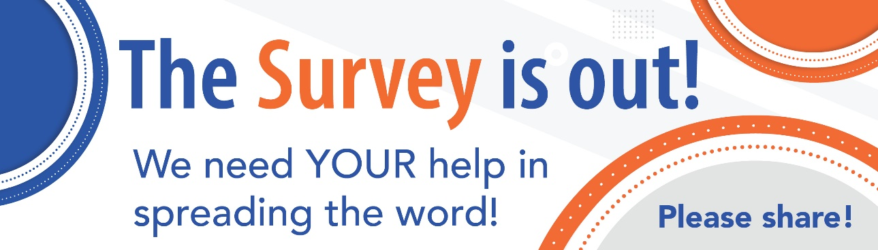
Email Subject: Help us develop a plan for the future of our region’s internet access

We’ve Launched a Public Survey to Help Improve Internet Access
We’re asking for your help. Please take the brief survey online or by phone about your internet usage, access, and experience.

You can win a $50 Visa gift card for completing the survey.

The input gathered from the survey is critical for the SWPA Connected team to develop programs that meet the needs of the region now and in the future. This initiative is not affiliated with any providers or intended to sell any internet services.

Take the survey online or by phone at 412-407-4555.

The improvement plan will outline and prioritize projects to bring high-speed broadband internet service to the communities that need it most.

The survey targets the 10-county region of Allegheny, Armstrong, Beaver, Butler, Fayette, Greene, Indiana, Lawrence, Washington, and Westmoreland.

Survey questions will include information about internet connection types, how the internet is used and satisfaction of services. All information collected will be anonymous.

About Our Partnership
The Southwestern Pennsylvania (SWPA) Connected is a regional consortium that includes the Southwestern Pennsylvania Commission (SPC), Carnegie Mellon University (CMU), Allies for Children, and a diverse group of regional partners to develop an equitable Connectivity Improvement Plan to provide affordable, reliable broadband internet access across the region.

This survey builds upon workshops and community conversations, in addition to research and analysis of current broadband internet access and gaps in the region. To learn more about the SWPA Connected initiative, visit www.spcregion.org/connected/.

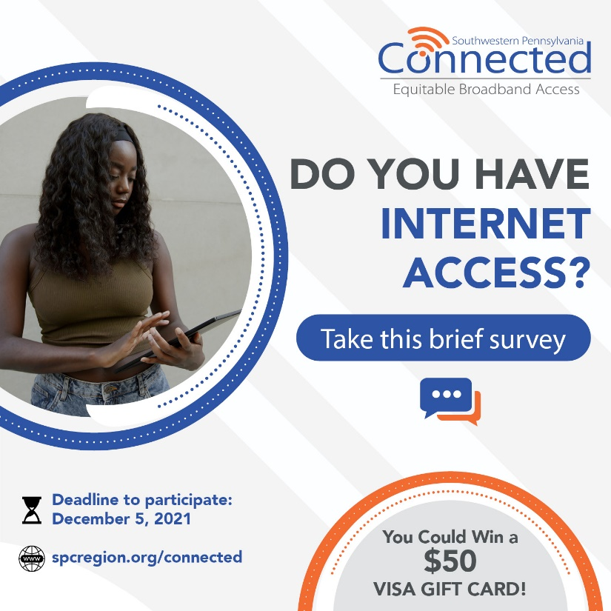 | Target:  Resident/Community  POST TEXT:  Do you have internet access?  We’re looking to improve our region’s access to affordable, reliable internet. (We’re not selling it!)  Take this brief survey so we can plan connectivity projects to help you in the future!  💻 Online: https://bit.ly/3w99EVA  ☎️ By Phone: 412-407-4555
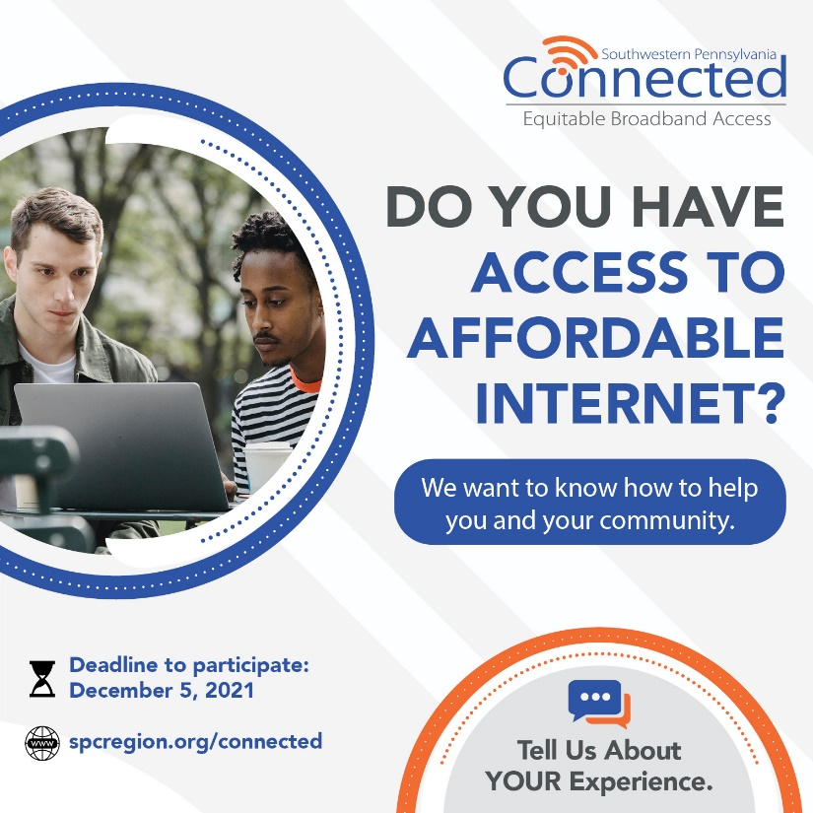 | Target:  Resident/Community  POST TEXT:  Do you have access to affordable internet?  We need to know how our residents and communities are currently served.  Take the survey & enter to win a $50 Visa gift card!  📲 Online: https://bit.ly/3w99EVA  📞 By Phone: 412-407-4555
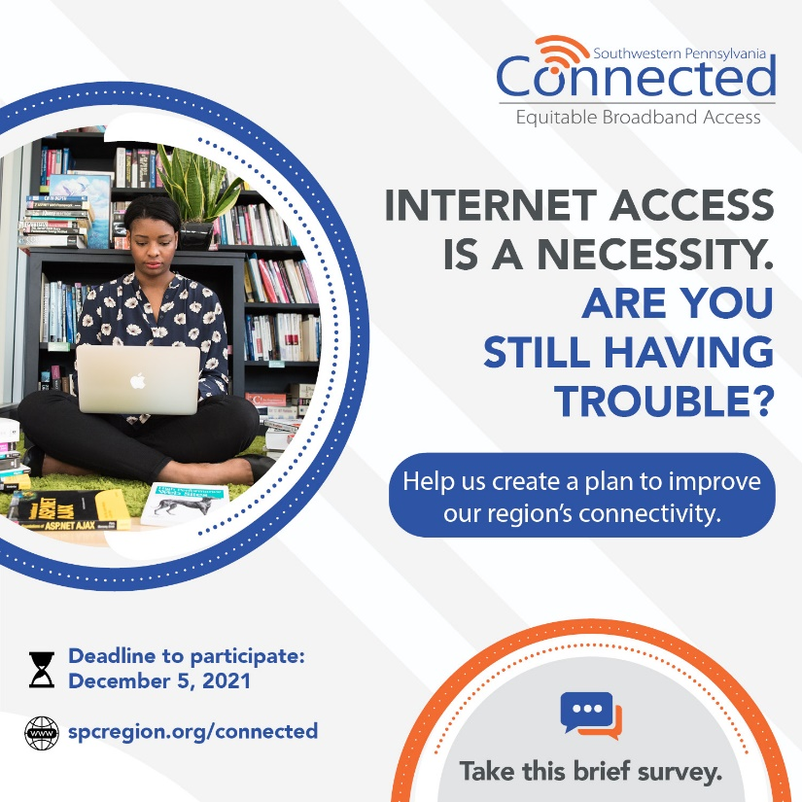 | Target:  Resident/Community  POST TEXT:  The pandemic showed us how important internet access is. We want to know if you have affordable, reliable access where you are.  ✍️ Let us know in this brief survey and you could win a $50 Visa gift card!  👩🏽‍💻 Online: https://bit.ly/3w99EVA  📱 By Phone: 412-407-4555
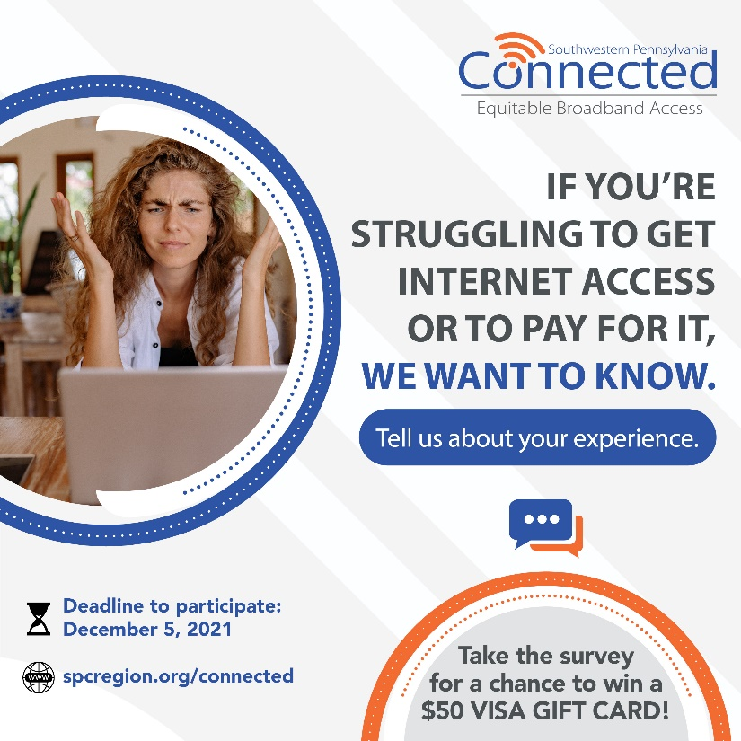 | Target:  Resident/Community  POST TEXT:  📢 No one should be without internet access anymore. We’re aiming to ensure all our communities have affordable, reliable access.  To do that, we need your help.  Tell us about your current internet access and how you use it.  Your info will be anonymous and will only be used to create a Connectivity Improvement Plan for the region.  👉 Online: https://bit.ly/3w99EVA  ☎️ By Phone: 412-407-4555
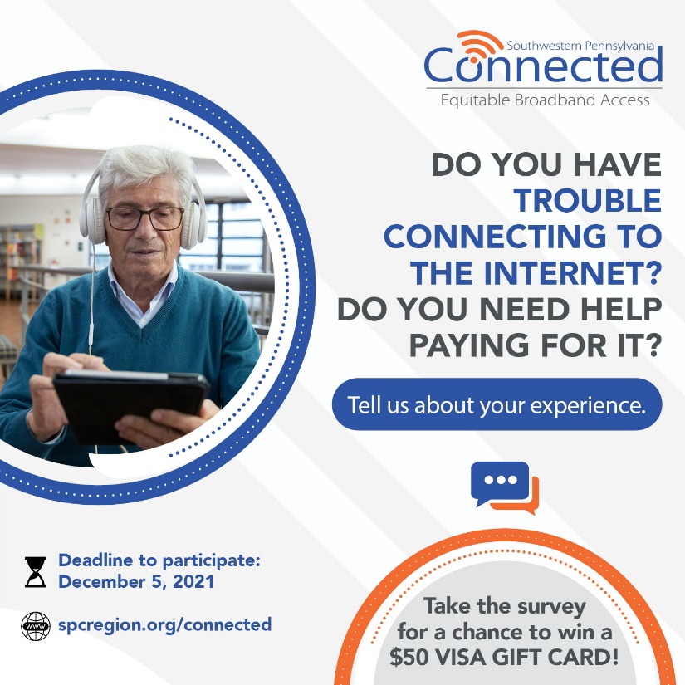 | Target:  Resident/Community  POST TEXT:  Make your voice heard and help us as we develop an improvement plan to provide affordable, reliable internet access to your community.  Take the survey & enter to win a $50 Visa gift card!  📲 Online: https://bit.ly/3w99EVA  📞 By Phone: 412-407-4555
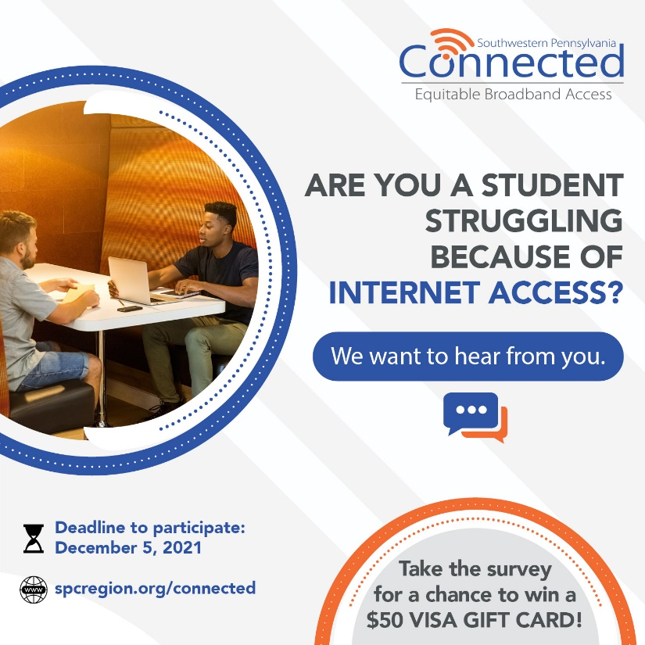 | Target:  Student/Parent/Educator  POST TEXT:  Do you have trouble doing your schoolwork because of internet access?  Take this brief survey to help us create a plan to help your future.  You could also win a $50 Visa gift card!  📲 Online: https://bit.ly/3w99EVA  📞 By Phone: 412-407-4555
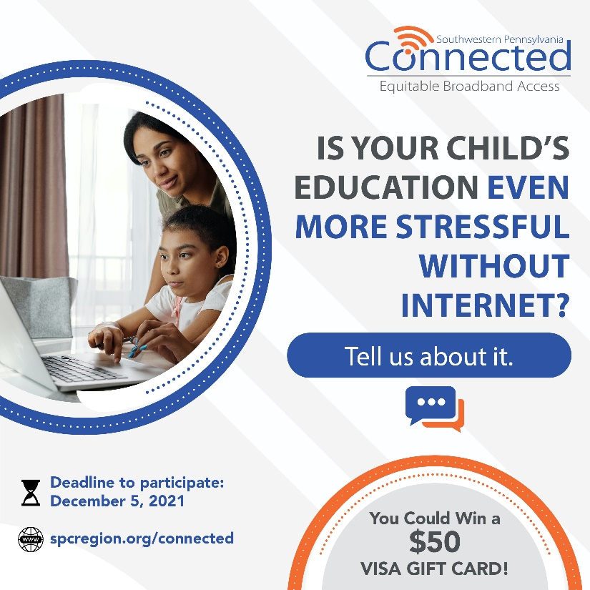 | Target:  Student/Parent/Educator  POST TEXT:  Is homework even harder than it needs to be because of internet access needs?  Help us help students like you by filling out this brief survey!  You could win a $50 Visa gift card, too!  👩🏽‍💻 Online: https://bit.ly/3w99EVA  📱 By Phone: 412-407-4555
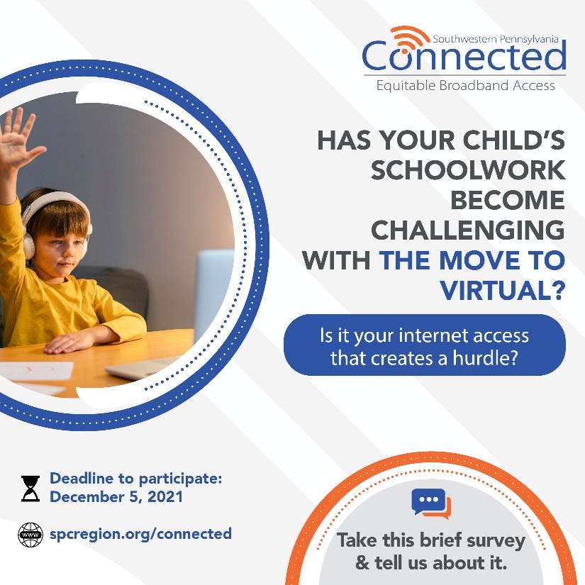 | Target:  Student/Parent/Educator  POST TEXT:  Is your children’s education even more stressful because of the need for internet access?  We’re looking to improve our region’s access to affordable, reliable internet. (We’re not selling it!)  Take this brief survey so we can plan connectivity projects to help you in the future!  💻 Online: https://bit.ly/3w99EVA  ☎️ By Phone: 412-407-4555
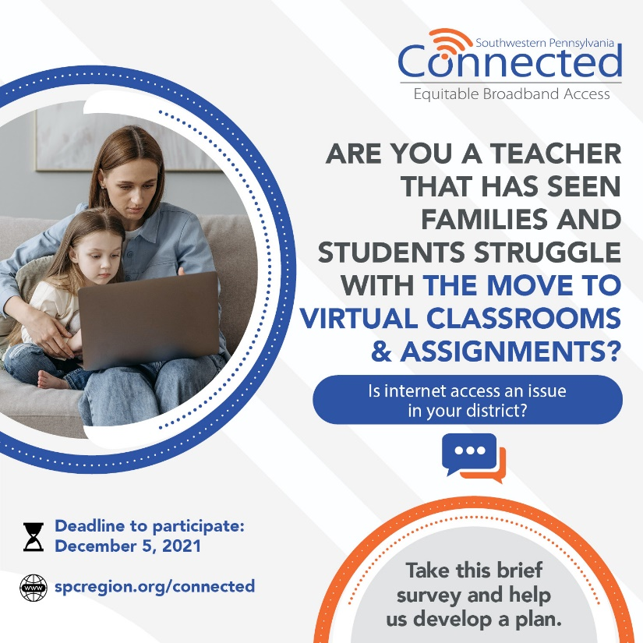 | Target:  Student/Parent/Educator  POST TEXT:  Are you aware of students and families impacted by their lack of affordable, reliable internet access?  We want to know how your communities are currently served and how we can help.  ✍️ Let us know in this brief survey and you could win a $50 Visa gift card!  👩🏽‍💻 Online: https://bit.ly/3w99EVA  📱 By Phone: 412-407-4555
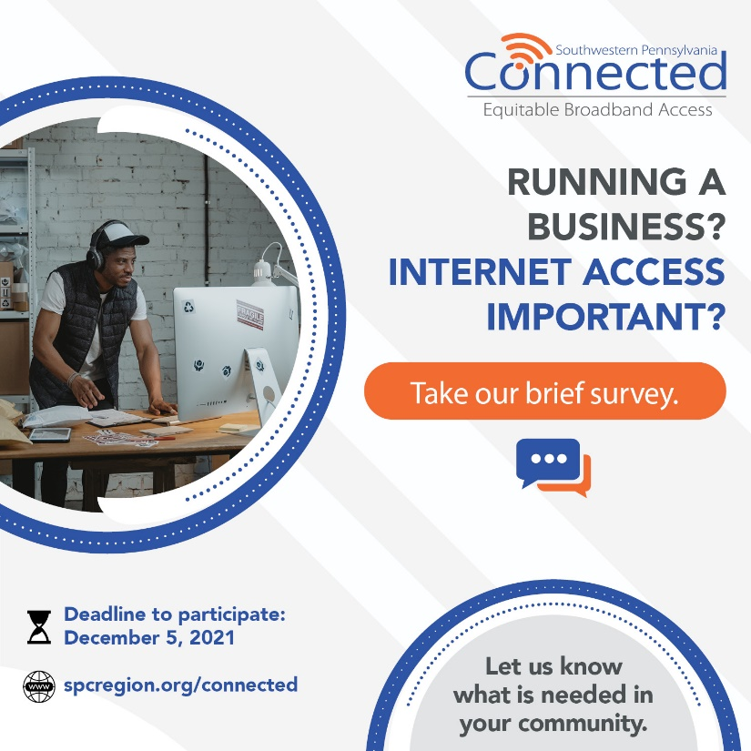 | Target:  Business Owner  POST TEXT:  Tell us about it. Take our survey 📑 and be a part of improving internet affordability + reliability in your community.  📲 Online: https://bit.ly/3w99EVA  📞 By Phone: 412-407-4555
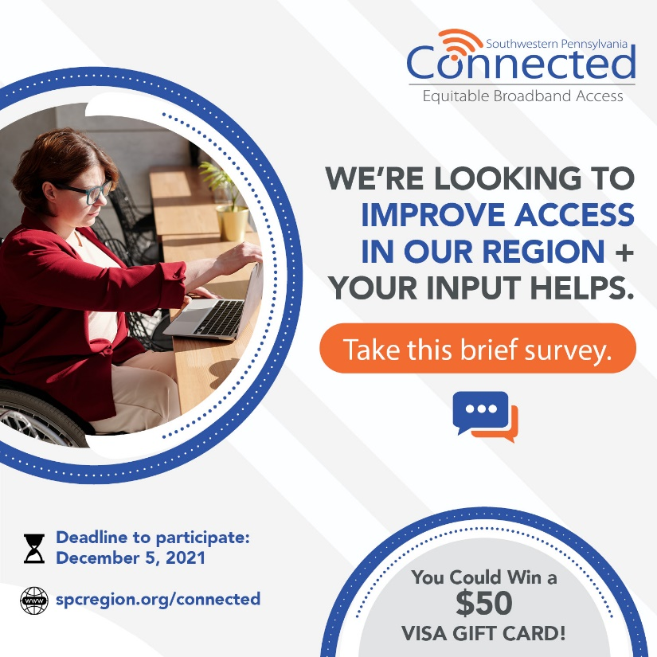 | Target:  Business Owner  POST TEXT:  We want your input. Please complete our internet usage survey and help us as we work to improve internet access in our region for all.  💻 Online: https://bit.ly/3w99EVA  ☎️ Phone: 412-407-4555
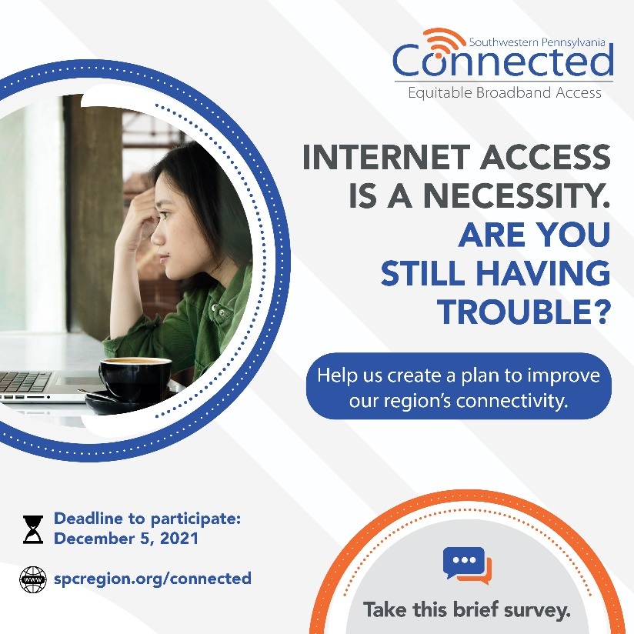 | Target:  Deadline Reminder: Any Stakeholder  POST TEXT:  🗣️ Make your voice heard and help us as we develop an improvement plan to provide affordable, reliable internet access to your community. Take the survey by 📅December 5! ⬇️  📲 Online: https://bit.ly/3w99EVA  📞 By Phone: 412-407-4555
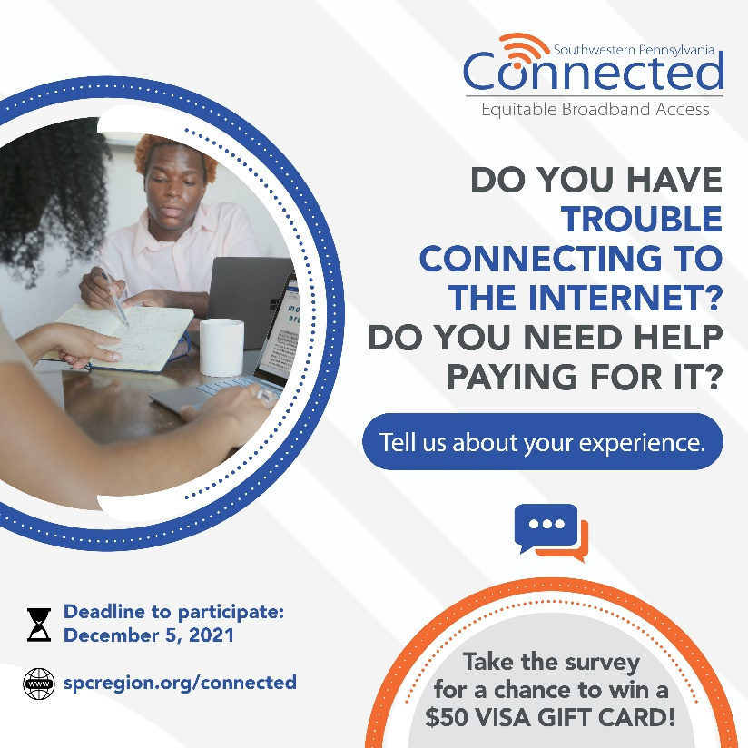 | Target:  Deadline Reminder: Any Stakeholder  POST TEXT:  ⏰ Time is almost up for you to tell us about your internet access and experience. Deadline to fill out the survey is Sunday, Dec. 5.  Don’t miss your chance to win a $50 Visa gift card!  💻 Online: https://bit.ly/3w99EVA  ☎️ Phone: 412-407-4555
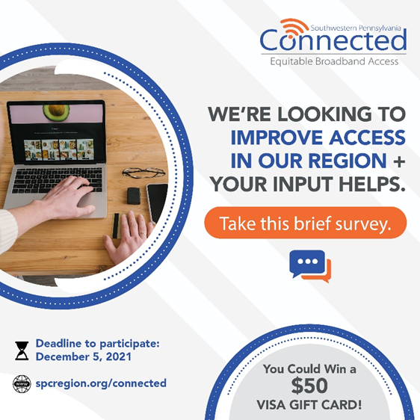 | Target:  Deadline Reminder: Any Stakeholder  POST TEXT:  ⏳ You still have time to tell us about it. Take our survey by this SUNDAY, Dec. 5 🗓️ and be a part of improving internet affordability + reliability in your community.  💻 Online: https://bit.ly/3w99EVA  ☎️ Phone: 412-407-4555

