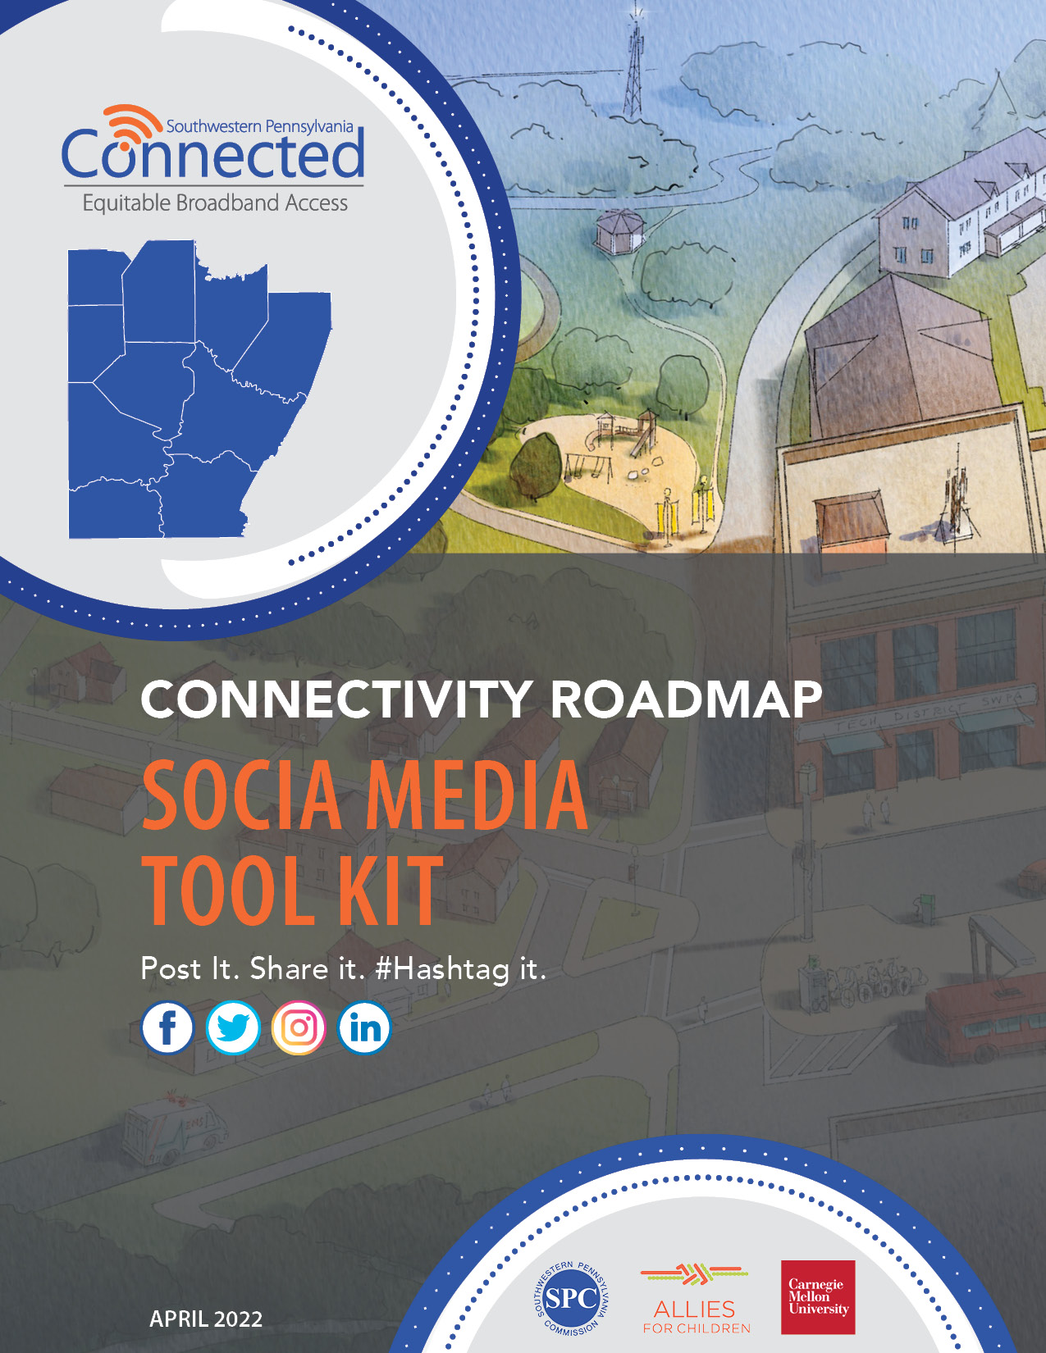

Social Media Tool Kit
This tool kit aims to provide helpful resources and materials to assist in raising awareness about the SWPA Connected initiative, the Connectivity Roadmap and to provide communities and residents across the 10-county region and the City of Pittsburgh the tools they need to increase their digital literacy and better advocate for improved internet access.

To learn more about the SWPA Connected initiative, visit www.spcregion.org/connected/.

Social Campaign - Hashtags
In all posts, please include the hashtag #SWPAconnected. The appropriate secondary hashtag is #Internet4all.

Hashtag: #SWPAconnected
Secondary Hashtags: #Internet4all, #ConnectivityRoadmap, #Broadband

Follow us & share our posts: @spcregion
https://www.facebook.com/spcregion
https://twitter.com/spcregion
https://www.instagram.com/spcregion/

About the Connectivity Roadmap
The Southwestern Pennsylvania Commission (SPC), in collaboration with Allies for Children, Metro21 and Traffic21 at Carnegie Mellon University, and a diverse, regional coalition of stakeholders, recognized the need for a regional Connectivity Roadmap to identify and guide the deployment of high-speed connectivity programs and projects throughout the southwestern Pennsylvania region.

Currently, many areas within the region lack adequate high-speed internet access and equipment that are essential for residents to better connect to jobs, education, health care, and to attract new business. This regional Connectivity Roadmap provides a guide for building a more comprehensive and equitable broadband network that will help people connect to opportunities.

The Connectivity Roadmap not only identifies regional goals, and how to identify projects, but also provides recommendations and next steps for the SPC, county and city leadership, and other partners to improve broadband infrastructure, tools, and skills across southwestern Pennsylvania.

Project Awareness Social Posts
Target: Resident/Community
POST TEXT:

#SWPAconnected is working to deliver affordable, reliable internet access to the communities in our region that need it most.

Learn more about the Connectivity Roadmap @ www.spcregion.org/connected.
#Internet4All
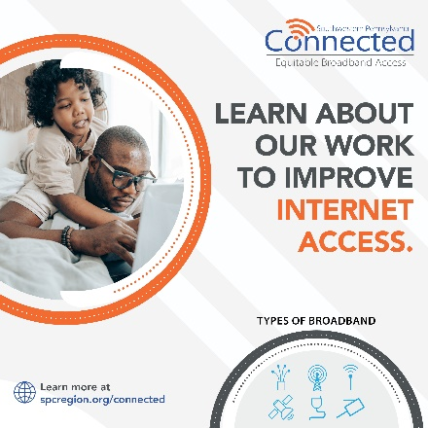  Facebook/Instagram | 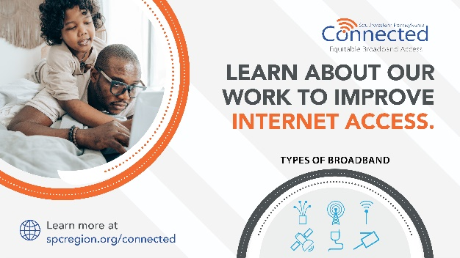  Twitter/LinkedIn
Target: Resident/Community
POST TEXT:

Different internet speeds control our online capabilities. Just having internet access is not enough. It needs to be high-speed, reliable, AND affordable.

That is what #SWPAconnected is working toward. Learn about the Connectivity Roadmap @ www.spcregion.org/connected.

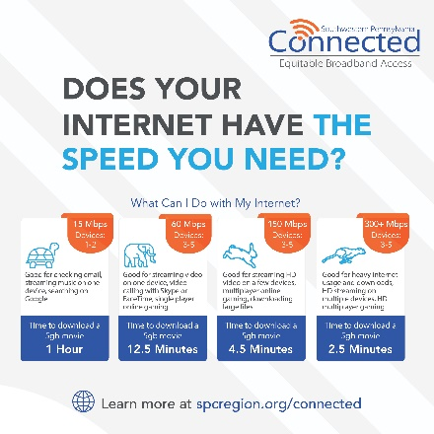  Facebook/Instagram | 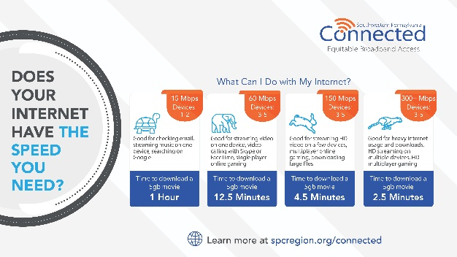  Twitter/LinkedIn
Target: Resident/Community
POST TEXT:

NO ONE should be without internet access.. #SWPAconnected is working TO ENSURE ALL our communities have affordable, reliable access.

Learn more about the Connectivity Roadmap @ www.spcregion.org/connected.

Facebook/Instagram  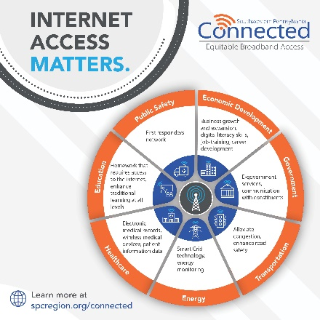 | Twitter/LinkedIn  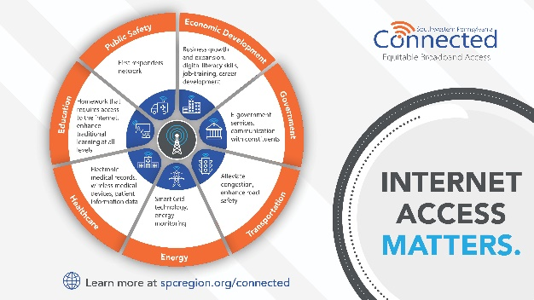
Target: Resident/Community
POST TEXT:

Understanding #internet terms can be confusing. Not all connections are equal or provide real access.

#SWPAconnected is working to deliver affordable, reliable internet access to the communities in our region that need it most.

Learn more about the #ConnectivityRoadmap @ www.spcregion.org/connected.

Facebook/Instagram  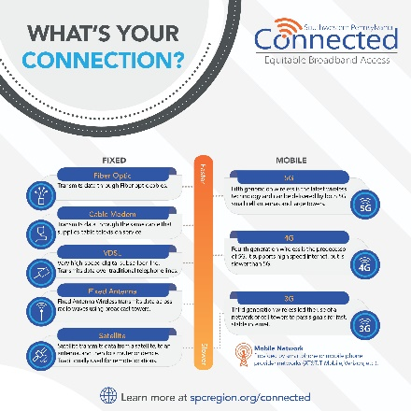 | 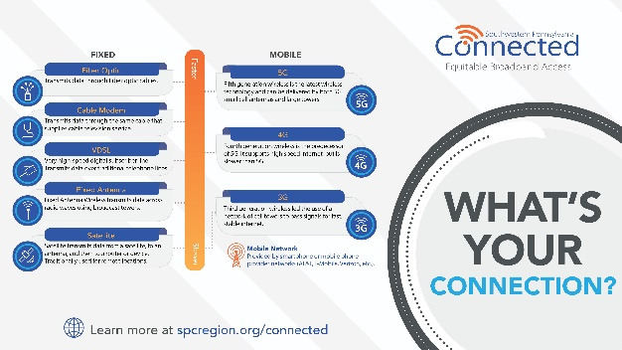  Twitter/LinkedIn

Target: Resident/Community
POST TEXT:

There are many ways the internet can come to you. Some are better than others in speed and reliability. #SWPAconnected is looking TO IMPROVE our region’s access to affordable, reliable internet.

Learn more about the Connectivity Roadmap @ www.spcregion.org/connected.

Facebook/Instagram  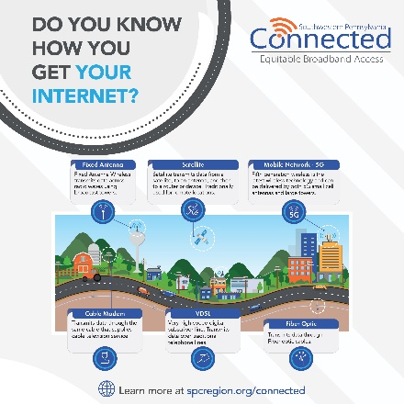 | Twitter/LinkedIn  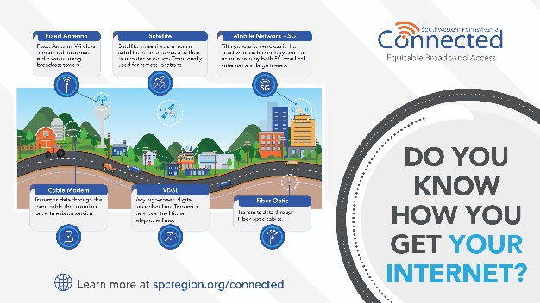
Target: Resident/Community
POST TEXT:

Educating about the importance of #broadband is just one of #SWPAconnected’s goals. Increasing digital literacy & understanding is another. Let’s work together to improve digital equity & inclusion in our region.

Learn about the Connectivity Roadmap @ www.spcregion.org/connected #Internet4all

Facebook/Instagram  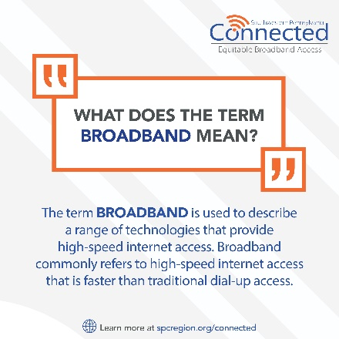 | Twitter/LinkedIn  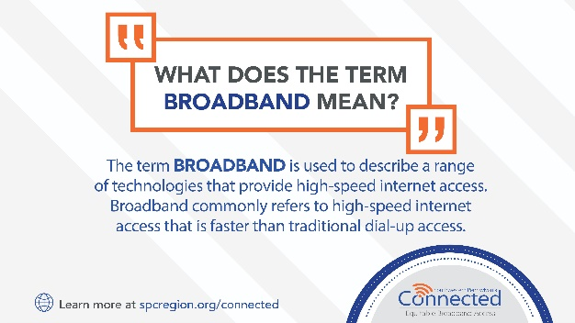

Target: Resident/Community
POST TEXT:

High-speed #internet IS ESSENTIAL for people and communities to thrive. It provides:
🎓 Improved Education
👩‍⚕️ Better Health
📈 More Business
📝 Increased Productivity

Check out the Broadband Benefits to My Community Fact Sheet @ www.spcregion.org/connected.

Facebook/Instagram  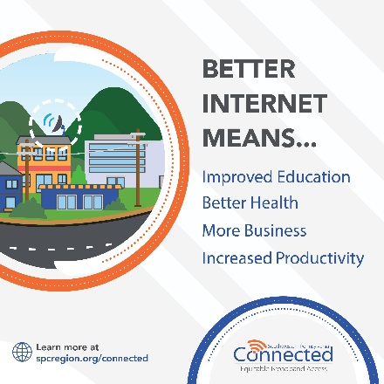 | Twitter/LinkedIn  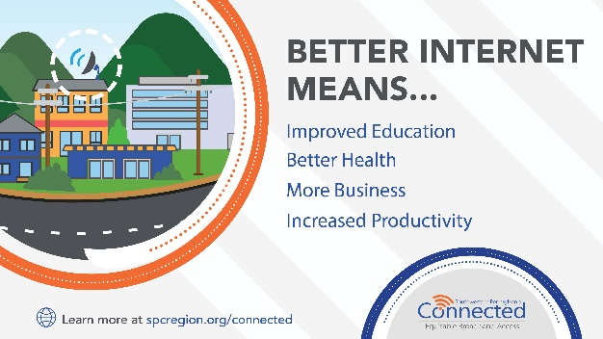
Target: Resident/Community
POST TEXT:

There are many great resources in the region TO HELP YOU gain the #computer skills needed to use the internet safely and confidently for your healthcare, school or work needs. The #SWPAconnected program aims to make finding those resources easier.

Check out the Expanding My Digital Knowledge Fact Sheet to find a class near you @ www.spcregion.org/connected.
Facebook/Instagram  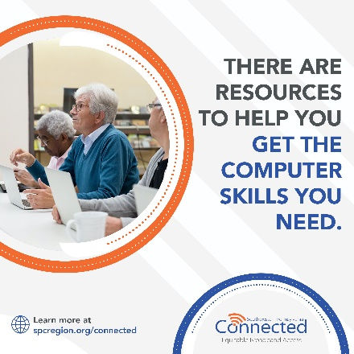 | Twitter/LinkedIn  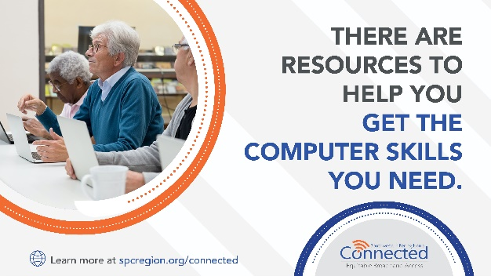
Target: Resident/Community
POST TEXT:

We’ve got you covered with #broadband terminology. Get the answer to this and many more definitions on our website.

Check out the Expanding My Digital Knowledge Fact Sheet to see common internet terms & definitions @ www.spcregion.org/connected.

Facebook/Instagram  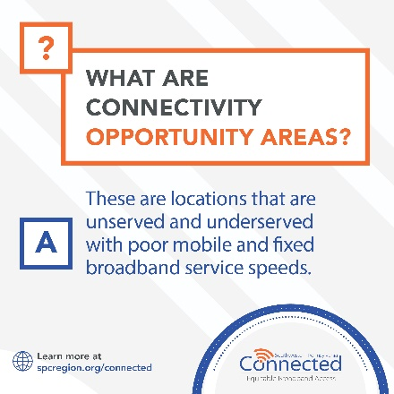 | Twitter/LinkedIn  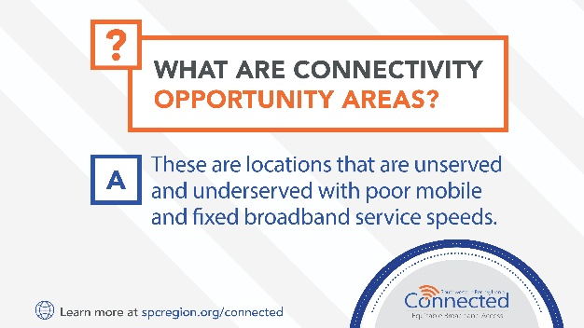
Target: Community & Partners
POST TEXT:

In the 10-county region – both rural & urban areas lack access to high-speed internet & equipment.
📲 Rural communities struggle with service being available.
💰 Urban communities struggle with the cost of service.
Once affordable, reliable internet is available, access to equipment & digital literacy is also vital.

#SWPAconnected and the Connectivity Roadmap includes a regional vision & goals to help deliver #internet4all. Learn more @ www.spcregion.org/connected.

Facebook/Instagram  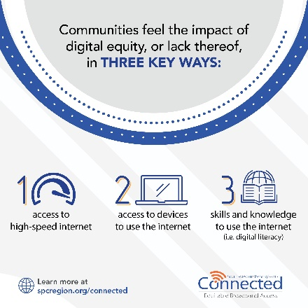 | Twitter/LinkedIn  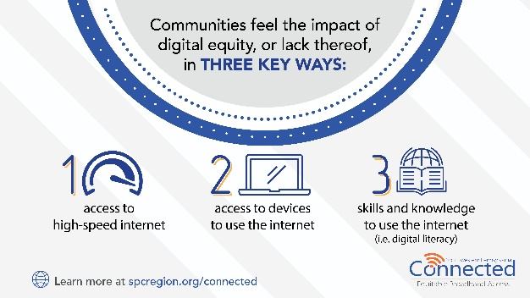
Target: Community & Partners
POST TEXT:

#SWPAconnected found that most of the 10-county region falls short of the 100/20 Mbps threshold that defines broadband & that the 2021 Infrastructure Investment Jobs Act requires of projects to qualify for gov’t funding.

Most of our region has download speeds LESS THAN 50 Mbps (underserved) or less than 25 Mbps (unserved)!

Check out the Connectivity Roadmap & join us in our Regional Vision to connect our community for growth @ www.spcregion.org/connected

Facebook/Instagram  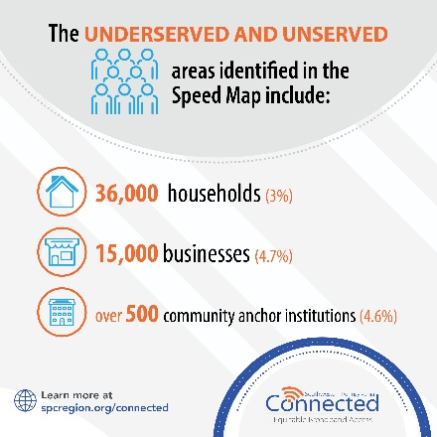 | Twitter/LinkedIn  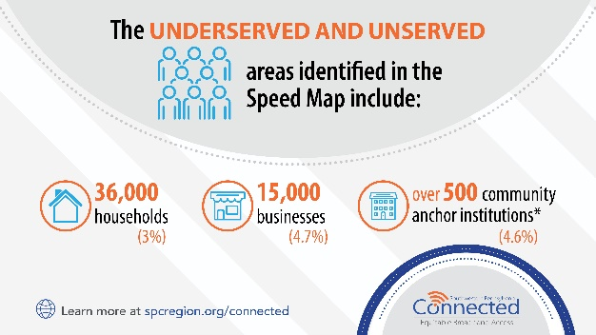
Target: Community & Partners
POST TEXT:

We heard from 3,445+ residents across the 10-county region in the public survey last fall about internet needs, satisfaction, and challenges. In addition, 63% feel their household would benefit from better home internet service.

Join #SWPAconnected in our Regional Vision to connect our community for growth @ www.spcregion.org/connected.

Facebook/Instagram  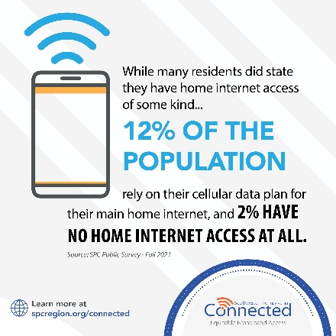 | Twitter/LinkedIn  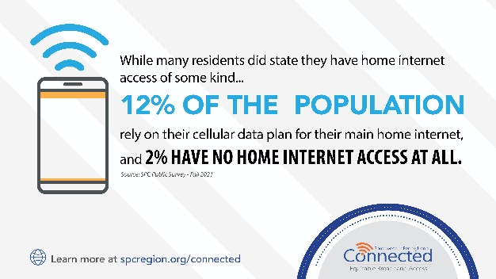
Target: Community & Partners
POST TEXT:

County or Municipal Leader in the 10-county SPC region? Check out the priority actions to guide connectivity projects in your communities.

Join #SWPAconnected in our Regional Vision to connect our community for growth @ www.spcregion.org/connected.

Facebook/Instagram  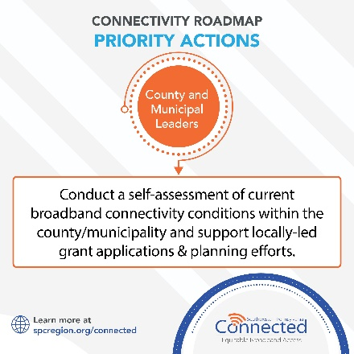 | Twitter/LinkedIn  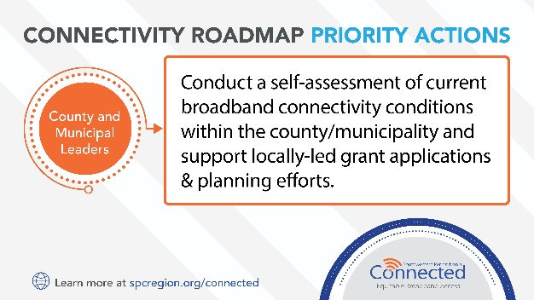
Target: Community & Partners
POST TEXT:

The Connectivity Roadmap provides tools to guide project selection, including:
- The Project Identification Decision Tree
- The Measures of Effectiveness
- Identified funding opportunities

14 initial projects have been identified based on county need & start with unserved areas that can pursue funding immediately. Check out the Connectivity Roadmap @ www.spcregion.org/connected.

Facebook/Instagram  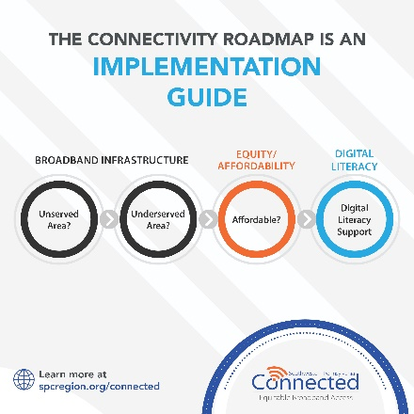 | Twitter/LinkedIn  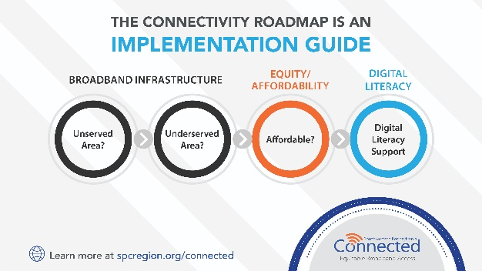
Target: Community & Partners
POST TEXT:

The Connectivity Roadmap was developed in partnership & through outreach to the 10-county region and the City of Pittsburgh to develop a regional vision & strategic goals to advance #broadband infrastructure across southwestern PA.

Join #SWPAconnected in our mission to connect our community for growth @ www.spcregion.org/connected.

Facebook/Instagram  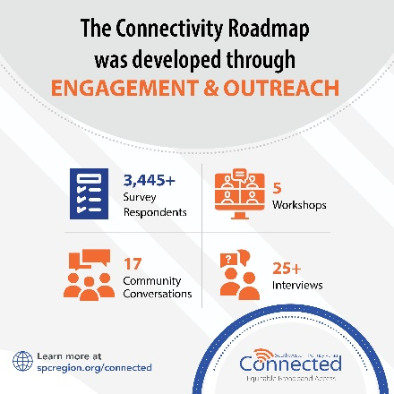 | Twitter/LinkedIn  